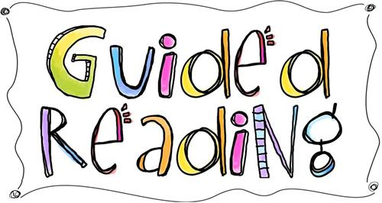
Guided Reading – Helping your child to develop their fluency when reading

Step 1. Explore the cover of the book. Look at colour, images and text. Talk about what clues they give you about the book. Is it fiction or non-fiction? What do you think it will be about? Why?
Step 2. Look the through the book together. Talk about how it is set out, any titles, images etc. Point out any key words that your child may not be familiar with.
Step 3. Read with your child. Take turns reading a section each. Point to the words as you read them. Model to your child that it is ok if you do not know a word. Show them ways to break it down – sounding out letters, breaking it up into syllables, looking at familiar parts of a word, reading the whole sentence to get clues about the meaning of a word, using a dictionary or glossary.
Step 4. Reread sections already read. Swap sections.
Step 5. Listen to your child read the whole section independently.

NOTE:
Steps 3,4,5 can be spread over a few days
If returning to the same book Step 1 should be a recap of what they read about last time and predicting what the next section might be about.

