How it works?
Step 1 – PREDICT
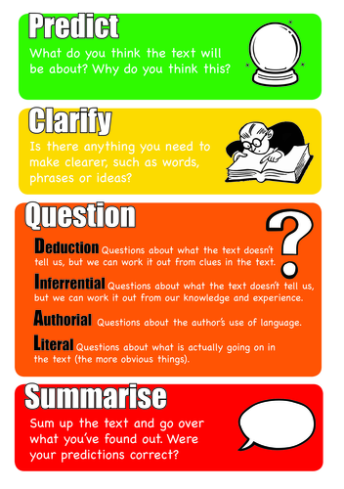
Choose a book or text to read with your child. Look at the title and first line. Make a prediction about the text. What will it be about? Why do you think this?

Step 2 – READ
Read a paragraph or short section of the text. If your child is able to read the text let them do so in their head. If your child is struggling to decode the words read it to them, asking them to join in with words that they recognise.

Step 3 – CLARIFY
Ask if there are any words, phrases that they need to clarify. Model how to find the meaning of words you do not know e.g. looking at familiar parts of a word, reading the whole sentence to get clues about the meaning of a word, using a dictionary or glossary, find images to support understanding where applicable. Show them it is ok not to know what a word means – no one knows everything! Help them by giving them strategies to use.

Step 4 - QUESTION
Ask your child if they have any questions about what they have read. Work out the answers together. Ask your child questions about what they have read (see question stems sheet for ideas).

Step 5 - SUMMARISE
Summarise what you have read. Identify the key points. Where your predictions right?

Step 6 – Repeat steps 1-5

